**Git Version Control**

Software development uses a distributed version control system called Git. By tracking code changes and allowing several developers to merge their modifications into a single repository, it enables them to work together on a project.

Some key features of Git include:

1. Distributed version control: Git allows numerous developers to work on the same codebase at once by storing multiple copies of a repository on various devices.
2. Creating distinct branches for various features or bug fixes and merging those branches back into the main codebase when they are complete are both possible with Git.
3. Git gives developers the option to stage their changes before committing them to the repository with a detailed note.
4. Git saves all of a project's history as a series of snapshots, enabling developers to quickly go back to earlier iterations if necessary.
5. Git offers solutions for resolving conflicts that arise when different developers make incompatible modifications to the same files.

**Git implementation**

If you are done installing Git then you will going to add the cmd path of the git.

C:\Program Files\Git\cmd

Add it to the environment variable

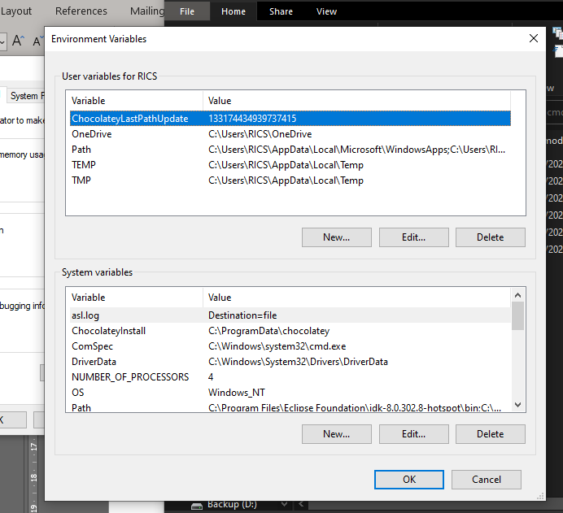

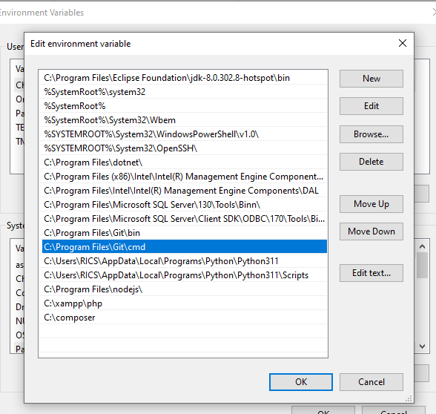

Sample Code

1. Create a repository in GitHub

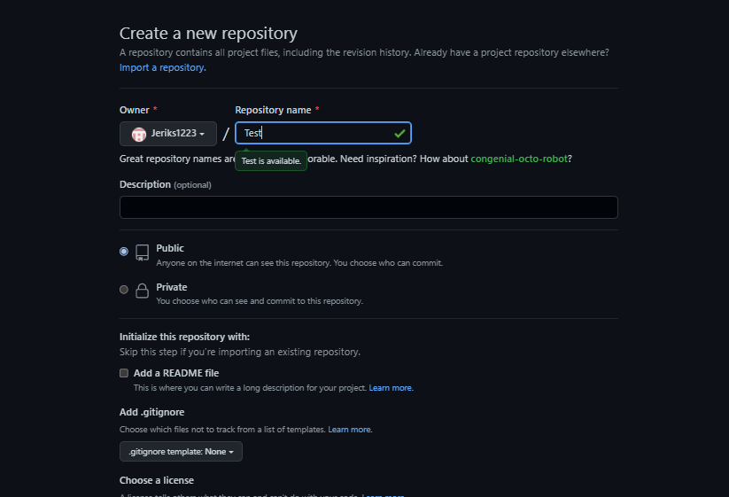

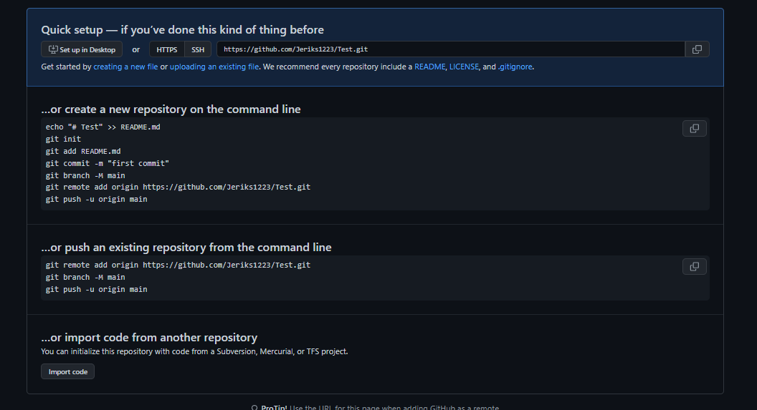

On pushing or committing the code or file just go to the file path of the file explorer.

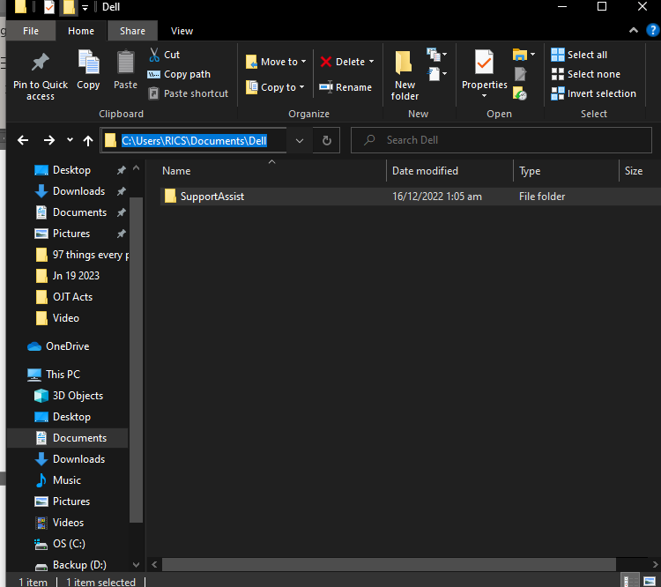

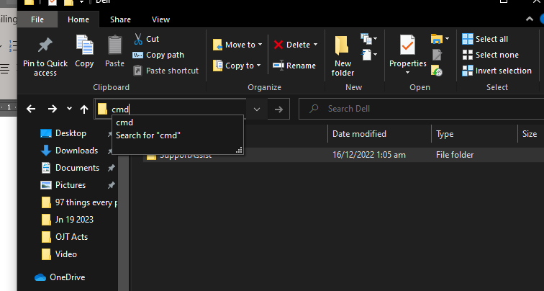

A cmd will appear after entering cmd.

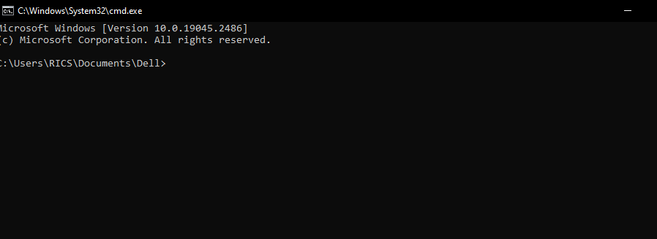

Type git init. 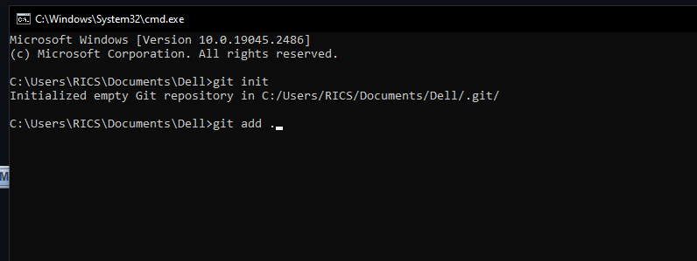

Type git add .



Type git commit -m "first commit"

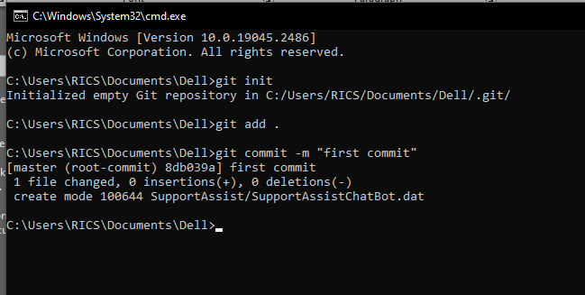

Type git branch -M main

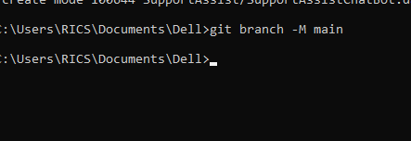

Type git remote add origin <https://github.com/Jeriks1223/Test.git>

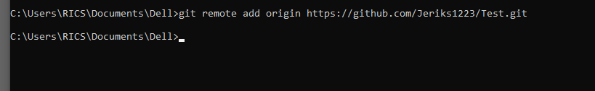

Type git push -u origin main.

